**Test plan**

The following Tests should be run to test various fields of the website.

|  |  |  |
| --- | --- | --- |
| Test Name | Specification | Expected Output |
| Unit testing | Testing an input field of the Form | Message for blank field submission attempt |
| Integration Testing | Testing a full integrated action and outcome | All the links should work fine to the last page of the function |
| Functional Testing | Testing a full function and show result | The function should be completed successfully. |
| Usability Testing | Testing user interface and usability | User should find a potential web interface |
| Security Testing | SQL testing | Errors should be shown for vulnerability |
| Browser Compatibility Testing | Running the CMS website in different browsers | All the browsers should run the website properly |
| Responsiveness Testing | Running the CMS website in different devices | Website should get resized for different dimensional displays of different devices |

**Unit Testing**

|  |  |  |  |  |
| --- | --- | --- | --- | --- |
| title | Pre-condition | Test steps | Expected result | Actual result |
| Form field test | Opening the Undergraduate Open Day Booking Form | From contact from, the Book on to an Open Day section should be selected and the page will open. Then book now button should be clicked | Input fields should show message for blank submission | Input fields show message for blank submission |

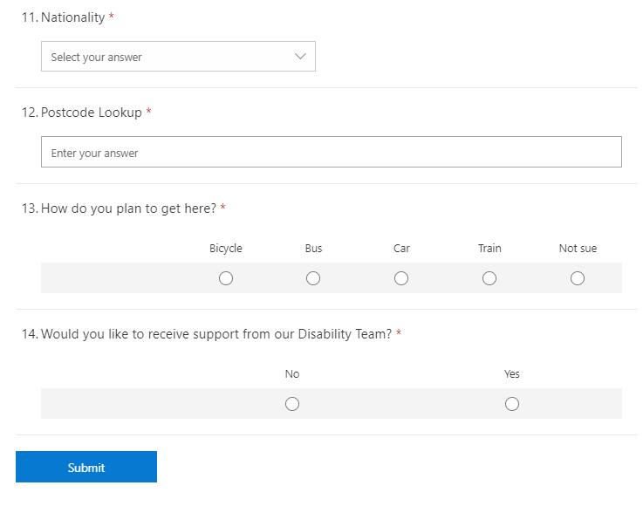

Form submission

Form should be filled

Figure: unit test

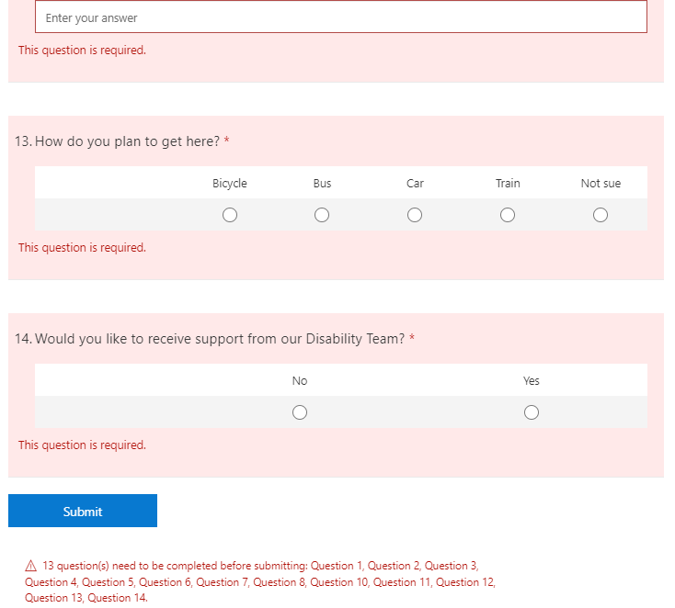

Warning message showed

Warning message showed

Figure: unit test

**Integration test:**

|  |  |  |  |  |
| --- | --- | --- | --- | --- |
| title | Pre-condition | Test steps | Expected result | Actual result |
| Undergraduate Open Day Booking test | Clicking the “contact us” link | The booking form should be filled up and submitted. Then the database and mail should be checked | The form data will be added to the database and a confirmation mail will appear | The form data added to the database and a confirmation mail appeared. |



Figure: integrated function’s continuous process

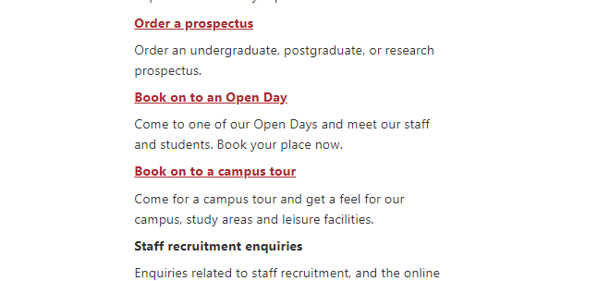

Open day booking page link



Open day booking form link

Figure: integrated function’s continuous process

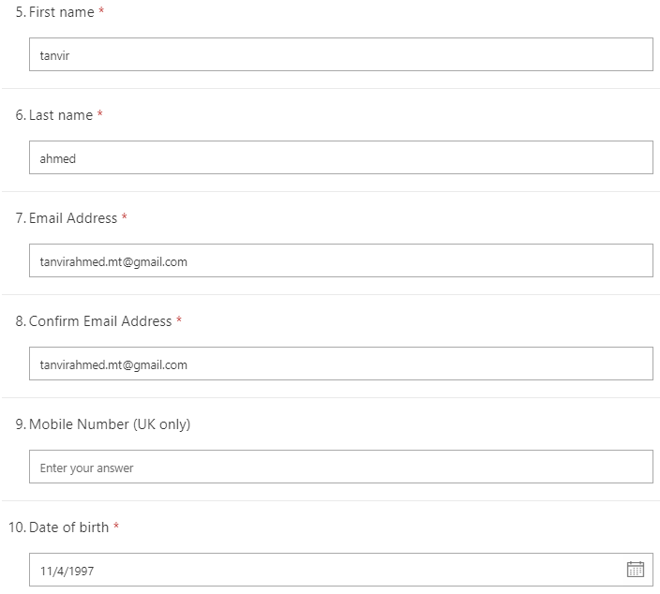

Booking form fill-up

Figure: integrated function’s continuous process

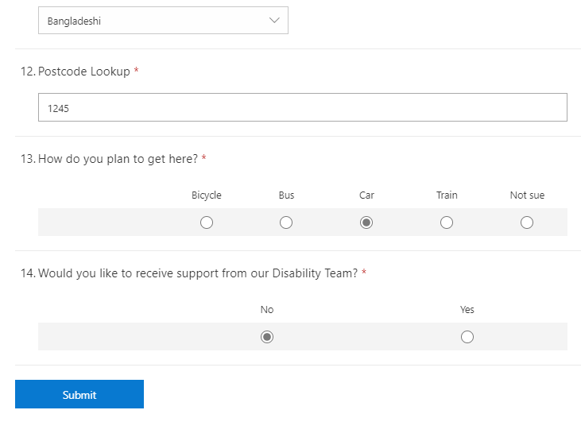

Submission after fill-up

Figure: integrated function’s continuous process

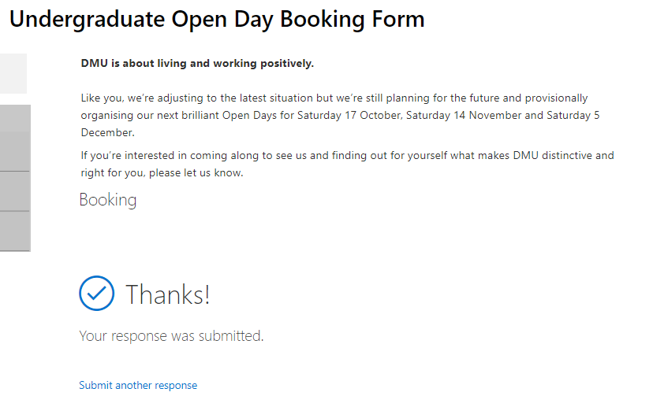

Successful submission message

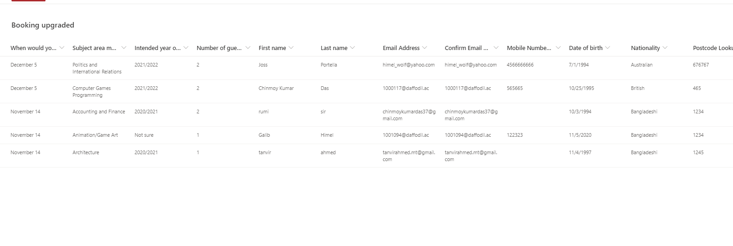

Updated database with the last submission

Figure: integrated function’s continuous process

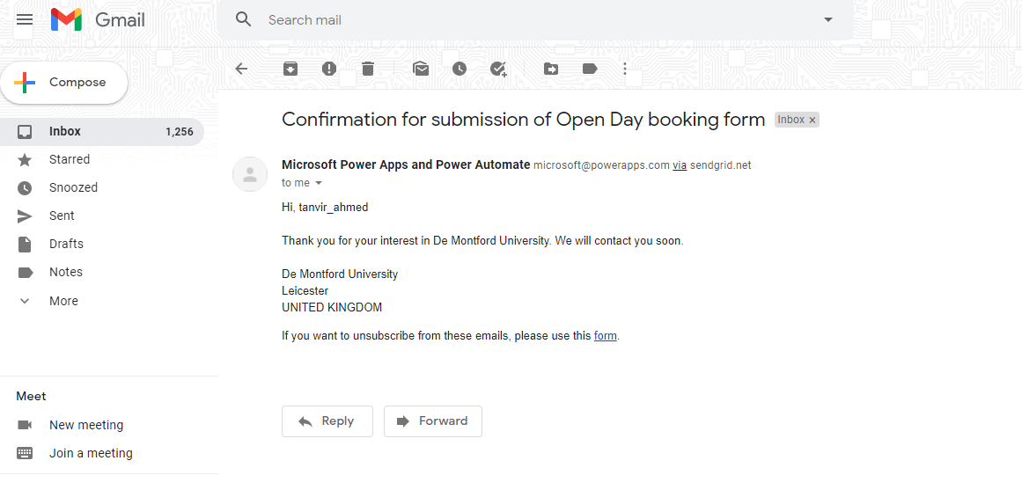

Confirmation mail for successful booking

Figure: integrated function’s continuous process

**Functionality testing:**

|  |  |  |  |  |
| --- | --- | --- | --- | --- |
| title | Pre-condition | Test steps | Expected result | Actual result |
| Study related enquiry test | Clicking the “contact us” link and choosing the Study and course related enquiry section | The enquiry form should be filled up and submitted. Then the database and mail should be checked. | The form data will be added to the database and a confirmation mail will appear | The form data added to the database and a confirmation mail appeared. |

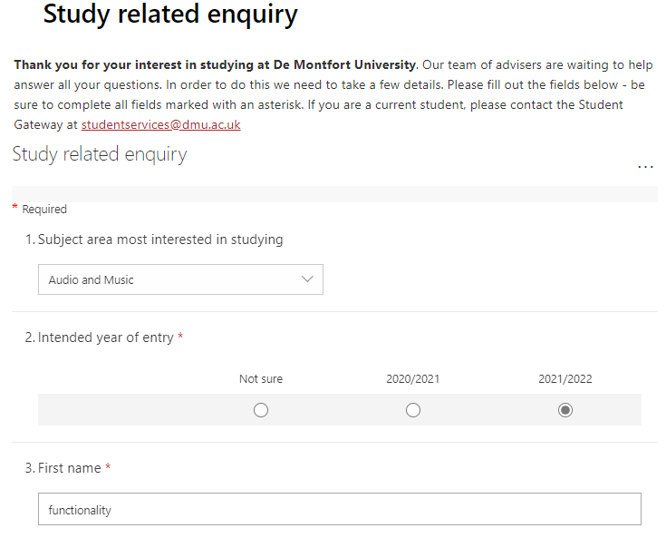

Enquiry form fill-up

Figure: information fill-up

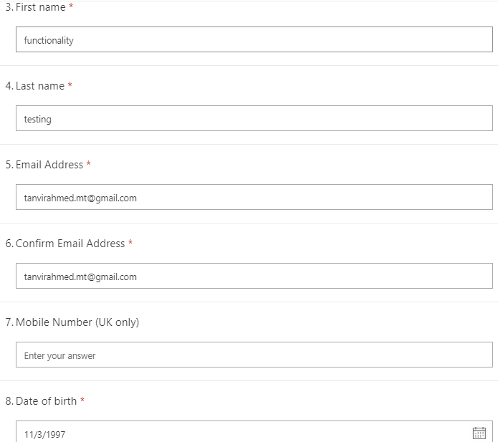

enquiry form fill-up

Figure: information fill-up

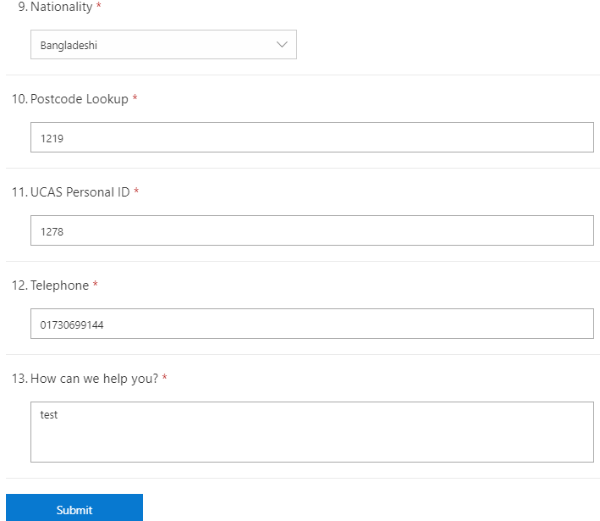

Submission after fill-up

enquiry form fill-up

Figure: information fill-up and submission

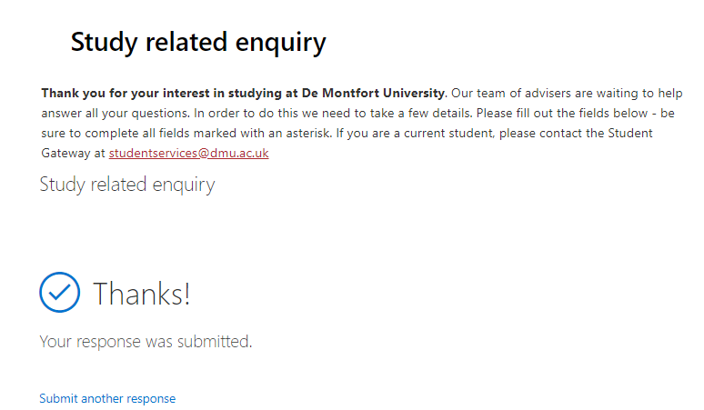

Successful submission message

Figure: submission successful message page

Updated database with the last submission

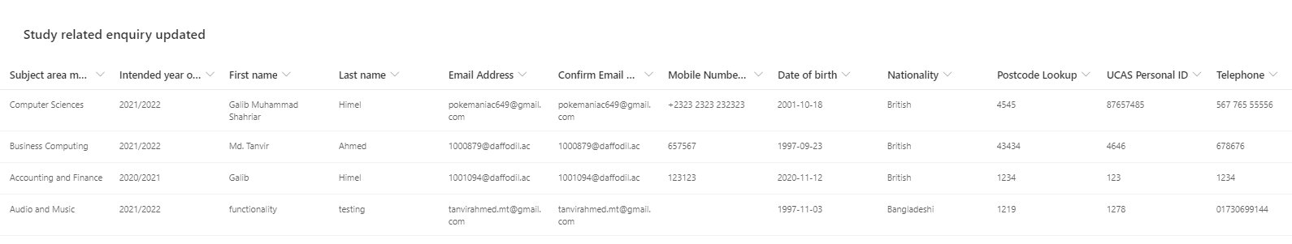

Figure: database updated with test data

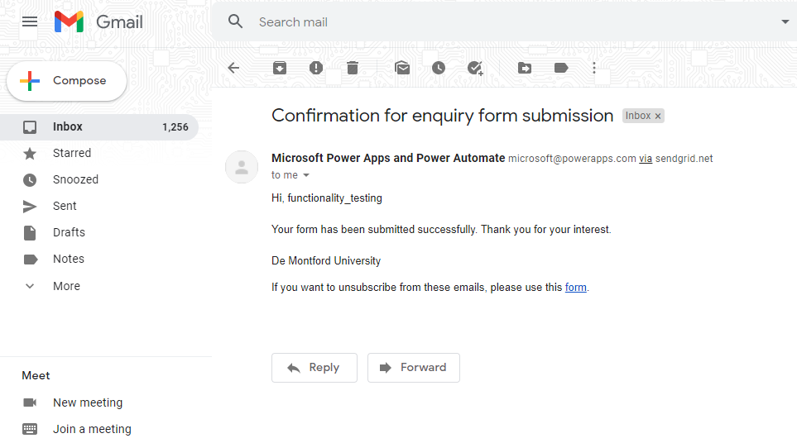

Confirmation mail for successful booking

Figure: mail confirmation

**Usability testing:**

|  |  |  |  |  |
| --- | --- | --- | --- | --- |
| title | Pre-condition | Test steps | Expected result | Actual result |
| User friendly nav-bar and hover effect | Opening the top of the website | Hovering the mouse cursor over the navigation buttons | Dropdown menu will open from each nav-buttons | Dropdown menu opens from each nav-buttons |

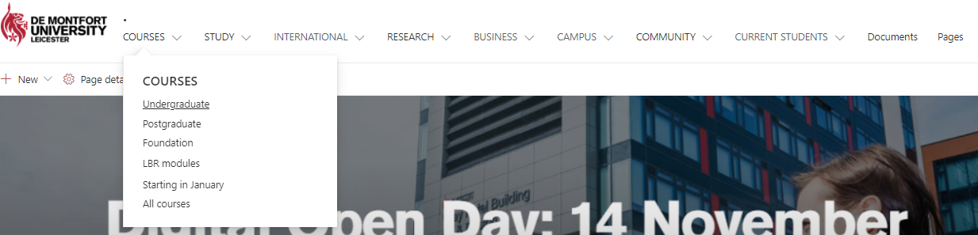

Navigation bar usability

Figure: usability test

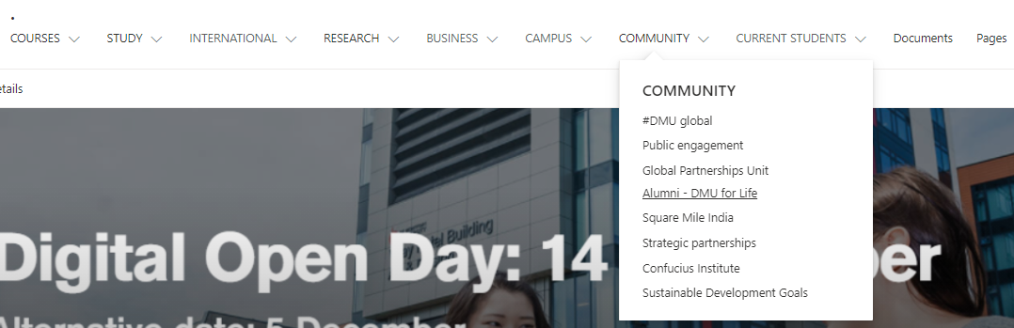

Navigation bar usability

Figure: usability test

**Security testing**

|  |  |  |  |  |
| --- | --- | --- | --- | --- |
| title | Pre-condition | Test steps | Expected result | Actual result |
| SQL injection testing | Having a SQL injection test tool | The CMS website link should be put into the tool | The tool will show errors for vulnerability | The tool show results for vulnerability |

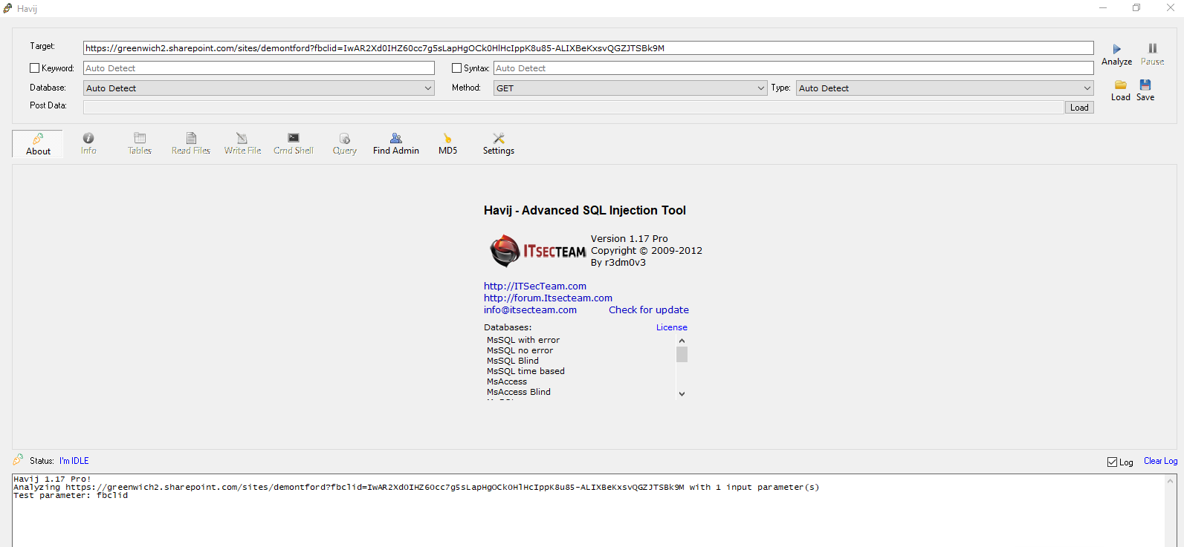

sql injection test result

sql injection test result

Figure: sql injection test result

sql injection test result

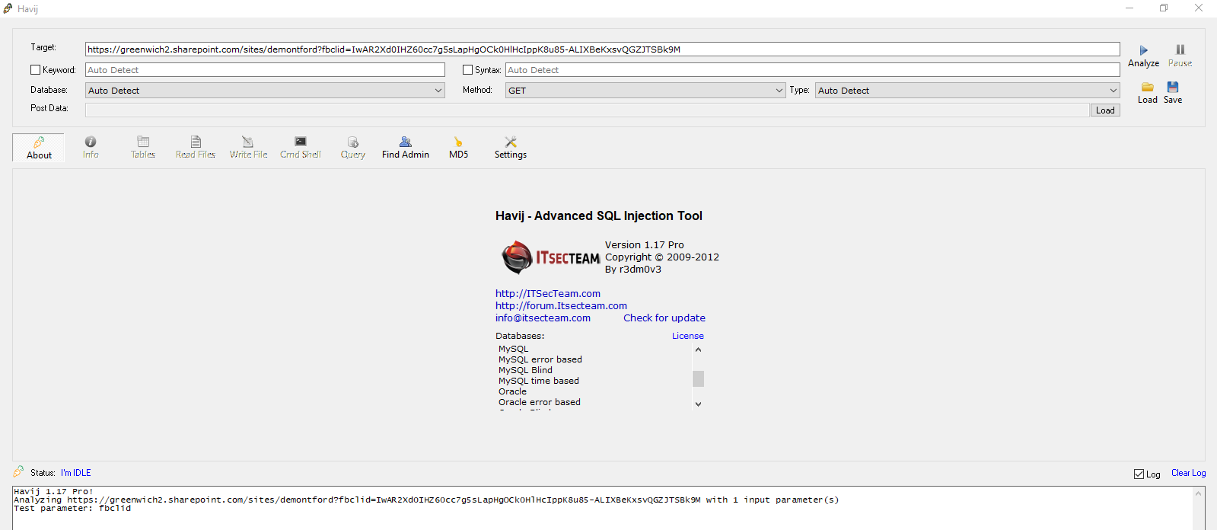

Figure: sql injection test result

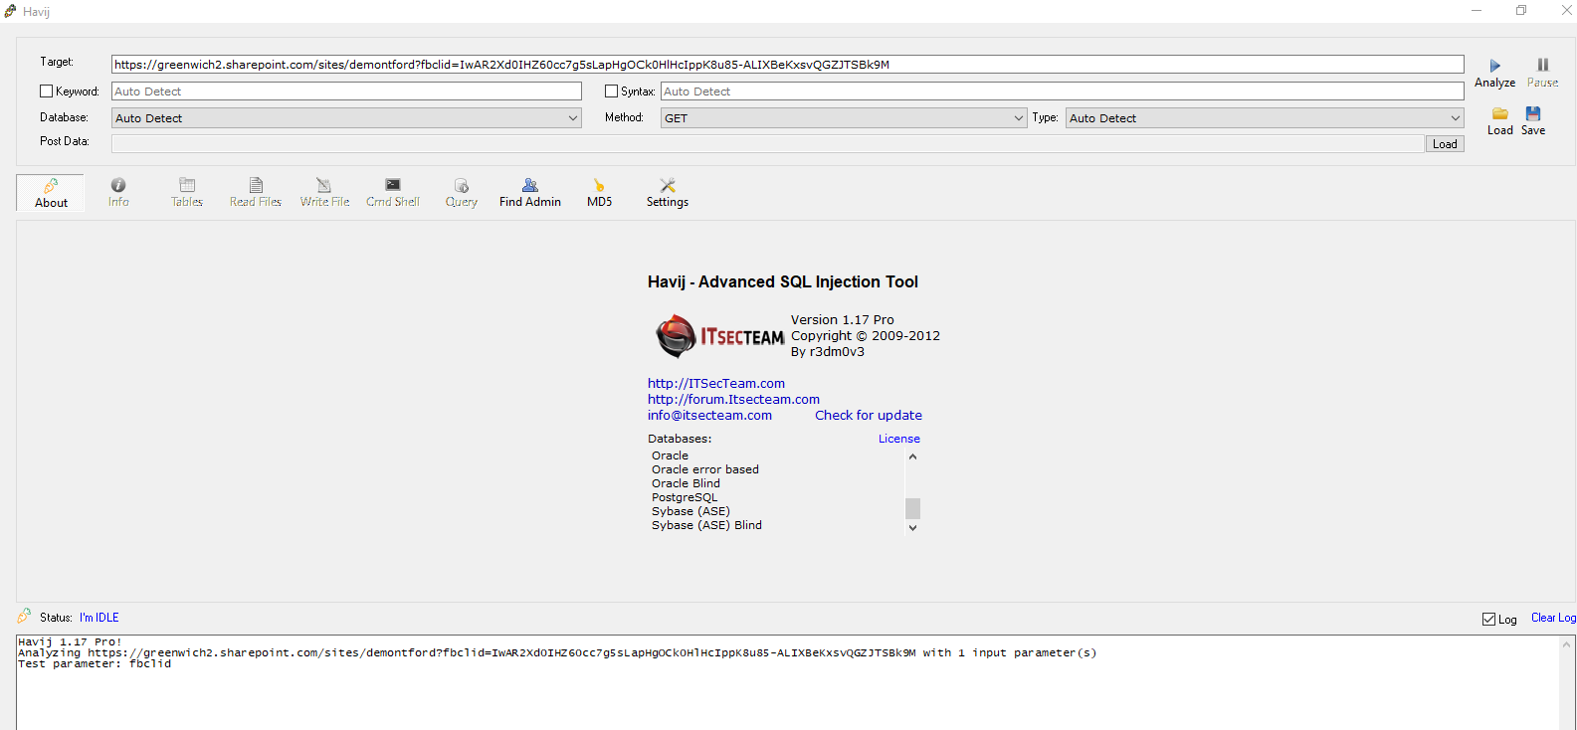

sql injection test result

Figure: sql injection test result

**Browser compatibility Testing:**

|  |  |  |  |  |
| --- | --- | --- | --- | --- |
| title | Pre-condition | Test steps | Expected result | Actual result |
| Compatibility test in Google chrome and Microsoft edge | Authorized Sign in on both browsers with SharePoint | Open Microsoft edge and Chrome and enter link of the CMS website. | Link will successfully open the website in both browsers | Link successfully opens the website in both browsers |

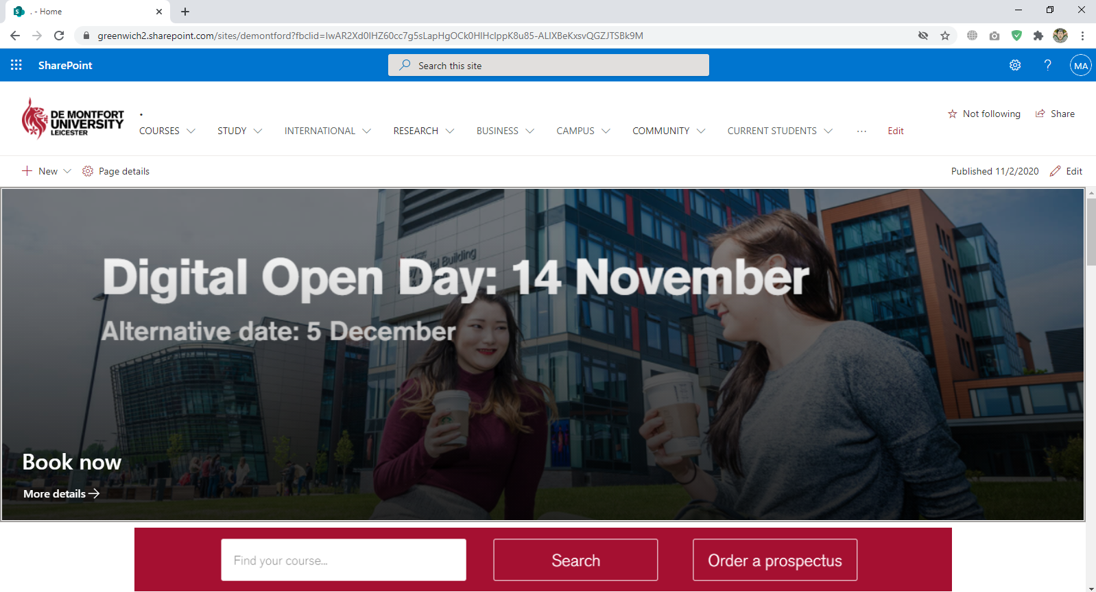

Figure: Google chrome compatible

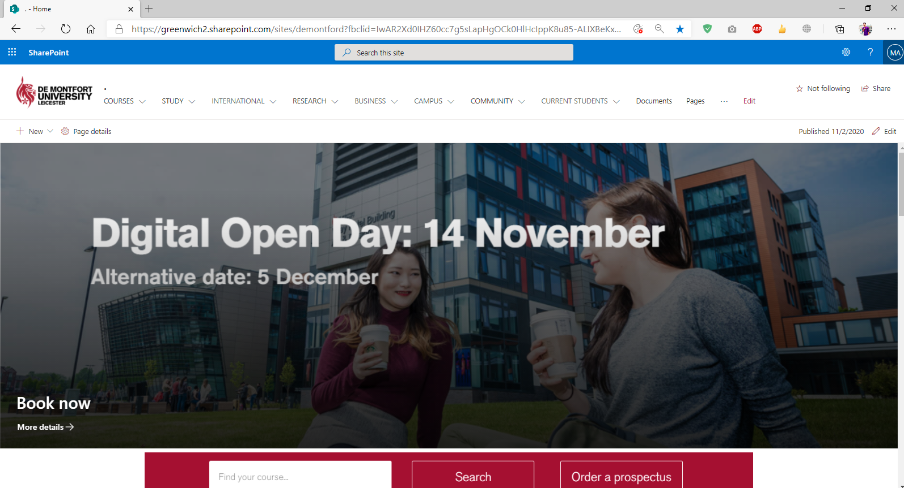

Figure: Microsoft edge compatible

**Responsiveness Testing:**

|  |  |  |  |  |
| --- | --- | --- | --- | --- |
| title | Pre-condition | Test steps | Expected result | Actual result |
| Multi device responsiveness | Having different dimensional devices | Open the CMS website in the test devices | Test devices will open the website with proper proportions | Test devices opens the website with proper proportions |

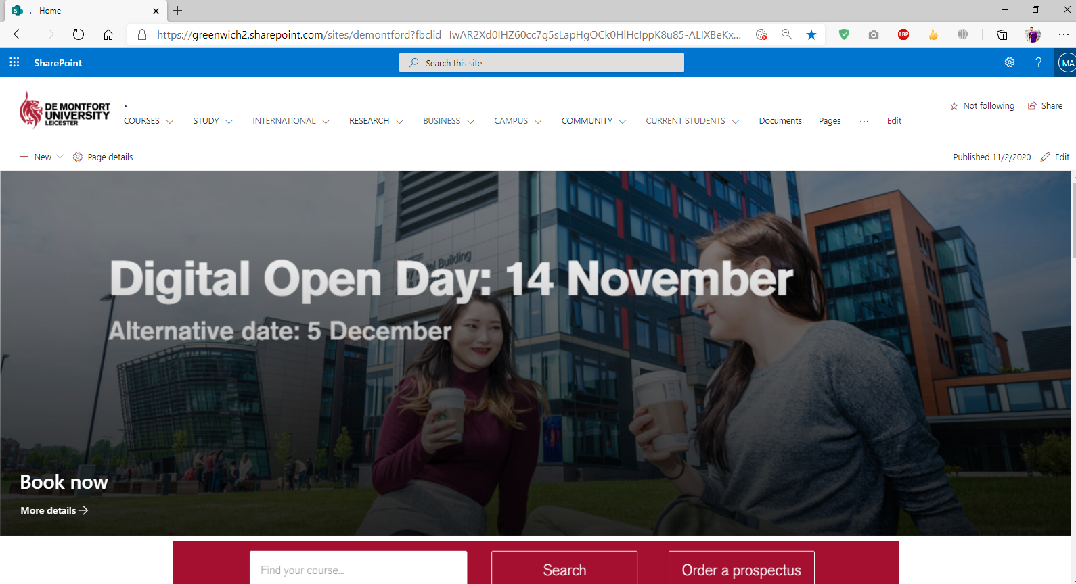

Figure: desktop view

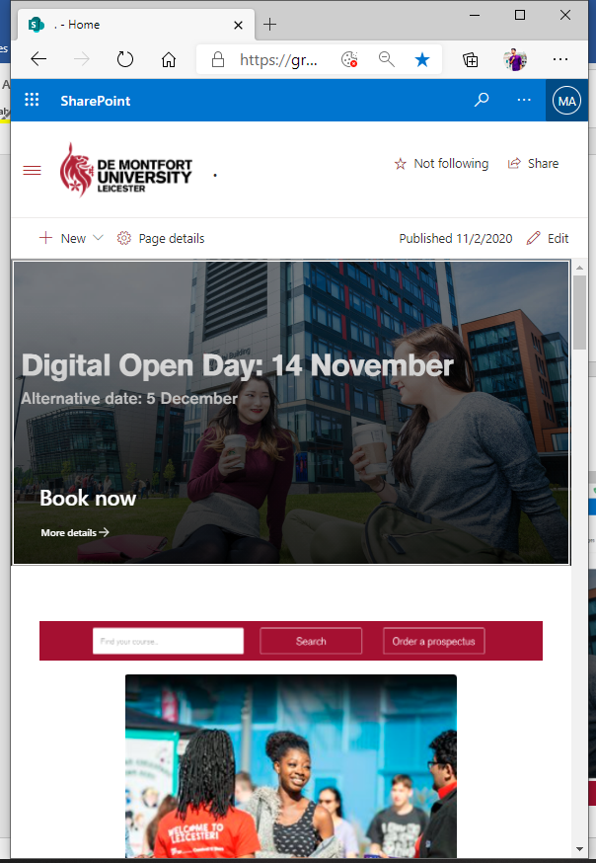

Figure: tab view

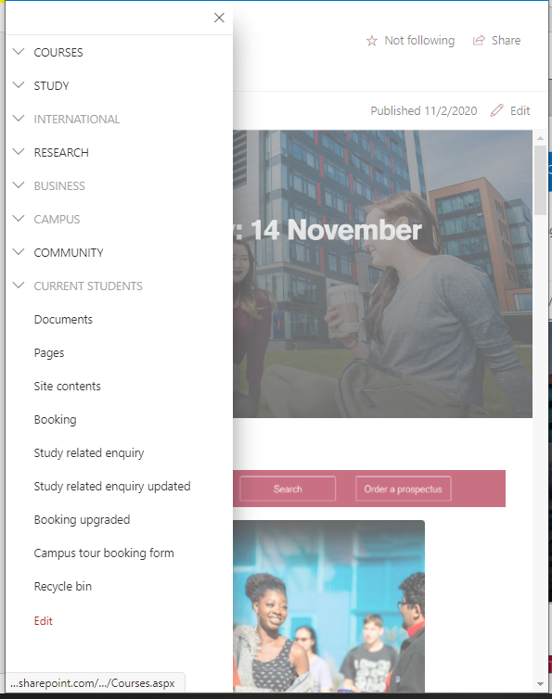

Figure: tab view of navigation bar